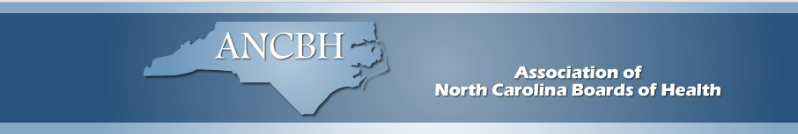

May 24, 2023

Hello Public Health Family: It has been the tradition of the Association of North Carolina Boards of Health to present three awards annually to fellow North Carolinians who have distinguished themselves in their service to public health in our state. We would like your help in nominating individuals or entire boards of health to receive these awards this year.

Carl Durham Award
Eligible: Institutional, Individual, Associate or Emeritus Member of ANCBH
Nominee:
- has made significant contributions to public health
- is an effective advocate for public health at the local, regional, and/or state levels.

Outstanding Board of Health Award
Eligible: ANCBH Institutional Member
Nominee:
- The board’s leadership in public health accomplishments must be clearly evident.
- The accomplishment must either have documented results or be currently producing intended results.
- The activity may be accomplished through the health department, other agencies, or groups.

Robert Ed Strother Partnership Award
Eligible: Individual
Nominee:
- Established and/or fostered a public-private partnership, which has improved public health for the community.

Nomination forms are available on the ANCBH website: https://www.ancbh.org/awards

You may submit your nominations by email to:
Merle Green, Executive Director, ANCBH
Email: merle.green@alamance-nc.com

Nominations are due by July 15, 2023. Winners will be notified by August 15, 2023. Awards will be presented at the annual ANCBH meeting on September 20, 2023. As always, thank you for your support of ANCBH and our awards program.

Jean Douglas Pharm.D., Chair, ANCBH
Revised: May 22, 2023

